


Module Code & Module Title
CC6057NI Applied Machine Learning
60% Individual Coursework
Submission: Milestone 1
AY 2025 2026
Academic Semester: Autumn Semester 2025
Semester Long Module
Student Name: Prashidha Rawal
London Met ID: 23048617
College ID: NP01AI4A230110
Assignment Due Date: Monday, December 15, 2025
Assignment Submission Date: Monday, December 15, 2025
Submitted to: Mr. Mahotsav Bhattarai
Github: imdb-review-classifier

I confirm that I understand my coursework needs to be submitted online via MST Classroom under the relevant module page before the deadline for my assignment to be accepted and marked. I am fully aware that late submissions will be treated as non-submission and a mark of zero will be awarded.

Table of Contents
1. Introduction 4
1.1. Overview of the Text Classification Project 4
1.2. Overview of Machine Learning Algorithms 5
1.2.1. Text Classification 5
1.2.2. Random Forest 6
1.2.3. Logistic Regression 7
2. Problem Domain 9
2.1. Detailed Explanation of the Selected Text Classification Problem 9
2.2. Description and Background Research on the Chosen Dataset 10
2.3. Brief Discussion of the Societal or Business Relevance of the Chosen Classification Task 11
3. Solution 12
3.1. Detailed Solution Walkthrough 12
3.1.1. Text Preprocessing 12
3.1.2. Features Extraction Methods 13
3.1.3. Machine Learning Algorithms/Models Implemented 14
3.2. Diagrammatic Representation 15
3.2.1. State Transition Diagram 15
3.3. Pseudocode 17
3.3.1. Data Loading & Preprocessing 17
3.3.2. Logistic Regression 21
3.3.3. Random Forest 23
3.4. Tools and technologies used 24
3.4.1. Tools and Technologies 24
3.4.2. Libraries 27
Bibliography 28

Table of Figures
Figure 1: Text Classification(GeeksForGeeks, 2024b) 5
Figure 2: RandomForest(Breiman, 2001) 6
Figure 3: Logistic Regression(GeeksForGeeks, 2024a) 8
Figure 4: Sigmoid Function(GeeksForGeeks, 2024a) 8
Figure 5: Preprocessing(GeeksForGeeks, 2025b) 12
Figure 6: TF-IDF(Shubham Chouksey, 2020) 13
Figure 7: State Transition Diagram(GeeksForGeeks, 2025a) 15
Figure 8: Whole System State Transition Diagram 16
Figure 9: Python(Python, 2024b) 24
Figure 10: MS Word(Nafiul Khan Earth, 2024) 24
Figure 11: Screenshot Taken from Desktop of Google Colab Notebook 25
Figure 12:Screenshot taken from Desktop of Github 26
Figure 13: Screenshot taken from Desktop of Kaggle 26

Introduction
This project falls under the Module Applied Machine Learning CC6057NI, which emphasizes on practical application of machine learning techniques, data visualization and representation for their real-world problems. The focus is on machine learning, building and evaluation of models that can learn from data to make predictions and classification decisions using concepts like supervised and unsupervised learning, feature engineering and performance metrics. By selecting a text-based task the project aligns with the module’s exploration of how machine learning intersects with natural language processing (NLP).
This Coursework major objective is to design and develop a text classification model prototype using python. This coursework lets us the freedom to choose our own dataset and implement at least two machine learning or deep learning models for text classification which can either be Logistic regression or RandomForest.

Overview of the Text Classification Project
This project focuses on developing a text classification model for sentiment analysis of movie reviews of letterboxd aiming to classify them as positive or negative reviews. Using Python and its machine learning libraries we will preprocess the data, extract necessary features, train multiple models, and evaluate their performance with metrics like accuracy and f1-score. The Letterboxd Movie Review dataset will serve as the primary source, providing a balanced set of labeled reviews to train and test the models while visualizingsuch word clouds and confusion matrices while helping in data exploration and result interpretation.

Overview of Machine Learning Algorithms

Text Classification
Text classification is a fundamental task in natural language processing and machine learning, where the goal is to assign predefined categories or labels to textual data based on its content. It involves training algorithms on labeled examples to recognize patterns, such as sentiments, topics, or spam indicators, enabling automated sorting and analysis of large volumes of text. Common applications include email filtering, sentiment analysis on social media, and document categorization in search engines. The process typically includes preprocessing steps like tokenization and vectorization to convert text into numerical features that models can process, addressing challenges like high dimensionality and linguistic variations(GeeksForGeeks, 2024c).
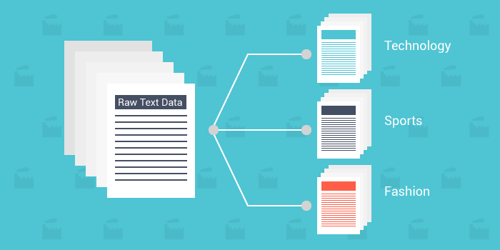
Figure 1: Text Classification(GeeksForGeeks, 2024c)

Random Forest
Random Forest is an ensemble learning algorithm that builds multiple decision trees during training and outputs the class that is the mode of the classes from individual trees, making it robust for classification tasks like sentiment analysis. It operates by constructing a "forest" of trees, each trained on a random subset of the data and features, which helps reduce overfitting and improves generalization(Breiman, 2001). In the context of movie review classification, Random Forest can effectively handle the high-dimensional feature space created by techniques like TF-IDF, where words or phrases are treated as features, allowing the model to capture complex interactions between terms that indicate positive or negative sentiment(GeeksForGeeks, 2024b).
This algorithm's strength lies in its ability to provide feature importance scores, which can reveal key words (e.g., "brilliant" for positive or "disappointing" for negative) driving the classifications in the movie reviews dataset. Additionally, Random Forest is less sensitive to noisy data and class imbalance compared to single decision trees, making it suitable for real-world text data that may include slang or varied writing styles. For this project, we will tune hyperparameters like the number of trees and maximum depth using grid search to optimize performance on the IMDB dataset(Python, 2024a).
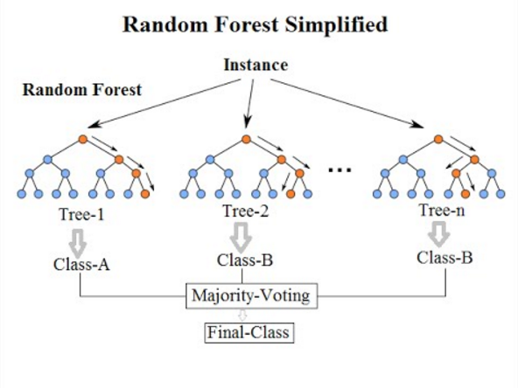
Figure 2: RandomForest(Breiman, 2001)

Logistic Regression
Logistic Regression is a linear classification algorithm that models the probability of a binary outcome using a logistic (sigmoid) function, making it well-suited for sentiment analysis where reviews are labeled as positive or negative. It works by finding the best fitting line (or hyperplane in higher dimensions) that separates the classes based on weighted features, such as those derived from TF-IDF vectorization of movie reviews. This simplicity allows for fast training and inference, even on large datasets like IMDB, while regularization techniques (e.g., L1 or L2) prevent overfitting by penalizing complex models(GeeksForGeeks, 2024).
In practice, Logistic Regression excels in text classification due to its interpretability, as the coefficients of features indicate the impact of specific words on the predicted sentiment positive coefficients for uplifting terms and negative for critical ones. For this project, it serves as a strong baseline model, often achieving high accuracy (around 85-90% on movie reviews) when combined with proper preprocessing like stop-word removal and stemming. We will evaluate it alongside Random Forest to compare linear versus ensemble approaches, highlighting how Logistic Regression handles sparse data efficiently(GeeksForGeeks, 2024).
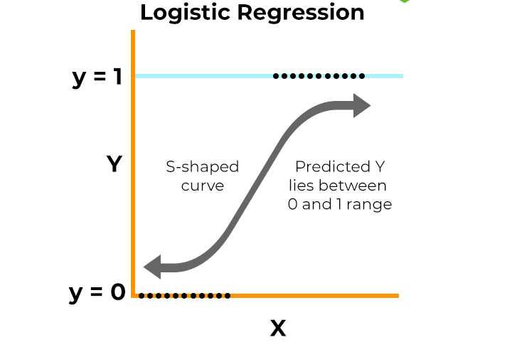
Figure 3: Logistic Regression(GeeksForGeeks, 2024a)

Sigmoid Function
A sigmoid function is a mathematical function used in machine learning, especially in logistic regression and neural networks, to map any real-valued number into a value between 0 and 1(GeeksForGeeks, 2024a).

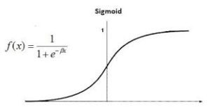
Figure 4: Sigmoid Function(GeeksForGeeks, 2024a)

Problem Domain

Detailed Explanation of the Selected Text Classification Problem

The chosen text classification issue is sentiment analysis of movie reviews of the IMDB data. Sentiment analysis is a natural language processing (NLP) sub-discipline, which helps to identify the emotional colors or opinion in a text, usually as positive or negative. In the present case, the task is binary classification where we are expected to guess the positive or negative nature of a movie review depending on the language and use of words and context of the reviewer.
This is a typical application of supervised machine learning in NLP whereby models are trained on text data that has been labeled to learn patterns that are related to sentiment polarity. An example is that the terms, such as `brilliant`, `engaging`, or `masterpiece` bear some positive connotation whereas such words as disappointing, boring, or waste bear negative connotation. The problem is with dealing with some of the nuances like sarcasm, negation (e.g. not ba which also means positive), domain specific jargon and different lengths of a review which may be covered by short phrases to in-depth essays. Preprocessing stages such as tokenization stop-word elimination, stemming/lemmatization and transformation into numerical values such as TF-IDF or bag of words are necessary to transform raw text into numerical features that can be input into classification algorithms.

Description and Background Research on the Chosen Dataset

The dataset in the question is the IMDB Movies reviews dataset, a widely used benchmark for the sentiment analysis and text classification tasks in NLP research. Originally compiled by Stanford University in 2011 as a part of their paper “(Maas et al., n.d.)” which was presented at the 49th annual conference of the Association for Computational Linguistics, it was sourced from user-submitted reviews on the internet movie database (IMDB) website. The Dataset is publicly available for download on HuggingFace or from the Stanford AI Lab website. It has also been mirrored in Kaggle and other dataset platforms for easy access.
Key characteristics include:
- Source and Collection: Reviews were collected/scraped from internet movie databases, focusing on highly polar opinions (rating 1-5 stars for negative and 7-10 stars for positive excluding neutral 5–6-star review to emphasize clear sentiment). No more than 30 reviews per movie was included to avoid bias from popular films.
- Size: The labeled portion consists of 50,000 reviews, split evenly between 25,000 for training and 25,000 for testing, An additional 50,000 unlabeled for unsupervised learning tasks.
- Number of Classes: 2 Binary Clasification: Positive and Negative sentiment.
- Class Distribution and Imbalance: The dataset is well balanced, with 12,500 positive and 12,500 negative reviews in both the training and test sets.

Since its release, the IMDB dataset has been mentioned in thousands of publications and served as a reference point to test NLP models, both classic machine learning families and neural networks including LSTMs and transformers. Indicatively, simple models of early studies had achieved about 80-85% accuracy, whereas current BERT-based models of 95%. It has more than the previous datasets, such as the Pang/Lee movie review dataset (2,000 reviews), with which they can be used to train it more vigorously.

Brief Discussion of the Societal or Business Relevance of the Chosen Classification Task

The implications of sentiment analysis on movie reviews are enormous in both the society and the business sector. Within the entertainment sector, it allows studios and platforms such as Netflix, Amazon Prime or IMDB to understand audience response in real time, predict how a movie will perform in the box office and how to adjust marketing strategies, e.g., why a movie did not do well based on the general complaints. It has value as a recommendation system in a business to create improved user engagement by recommending content in line with the positive sentiment, which leads to revenue via subscriptions and advertisements. On the social level, it helps to gain knowledge about the cultural trends, general attitude to social problems shown in films (e.g., the topic of diversity or environment), and even the psychological knowledge based on the summary of emotional reactions. This task is beneficial in general NLP applications to build customer feedback analysis tools in any industry such as e-commerce or social media to help make products and services responsive. Ethical considerations however involve alleviating training data biases which may enhance stereotyping in film reviews.

Solution

Detailed Solution Walkthrough

Text Preprocessing
Text preprocessing is a critical step in preparing raw movie reviews from the IMDB dataset for classification. It involves cleaning and normalizing the text to reduce noise, handle variations in language, and make the data more suitable for feature extraction(DataCamp, 2024). The following techniques were employed:
- Tokenization: Splitting the text into individual words or tokens. This breaks down sentences into manageable units, handling punctuation and contractions (e.g., "don't" → ["do", "n't"]). It forms the foundation for further processing(GeeksForGeeks, 2025b).
- Stop Word Removal: Eliminating common words that add little meaning, such as "the", "is", "and", "a". This reduces the feature space dimensionality and focuses on content-rich words, improving model efficiency without losing sentiment cues(GeeksForGeeks, 2025b).
- Stemming/Lemmatization: Reducing words to their base or root form. Stemming (e.g., Porter Stemmer) chops off suffixes (e.g., "running" → "run", "movies" → "movi"), which is fast but sometimes crude. Lemmatization is more accurate, using vocabulary and morphological analysis to return the proper lemma (e.g., "better" → "good"). Lemmatization was preferred here for better preservation of meaning in diverse review language(GeeksForGeeks, 2025b).
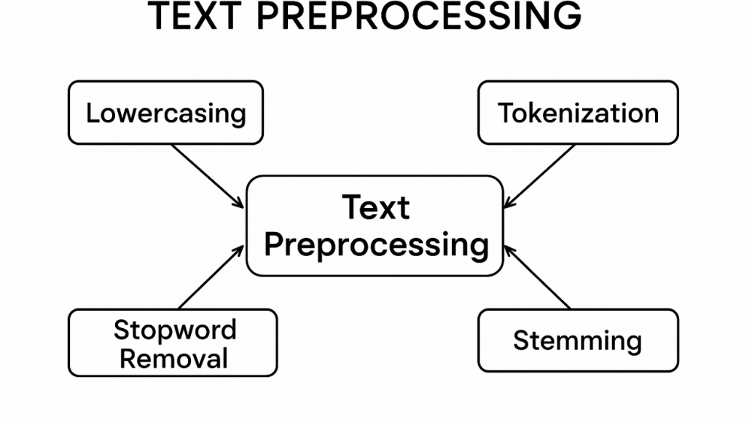
Figure 5: Preprocessing(GeeksForGeeks, 2025b)

Features Extraction Methods
The feature extraction converts text that has been preprocessed into numerical vectors to be processed by machine learning models. In this IMDB sentiment analysis assignment:
TF-IDF (Term Frequency-Inverse Document Frequency): The main technique is this one. It computes the weight of every word depending on its frequency in a review (TF) and its uncommonness in the corpus (IDF). This shows words that are discriminative (e.g., "masterpiece" will be high weight in positive reviews when used rarely overall) as well as scaled down common words. Applied with options such as bigrams (ngram range (1,2)) to get phrases such as highly recommend. TF-IDF is especially useful with sparse textual data such as movie reviews that give high-dimensional vectors that are informative(Shubham Chouksey, 2020).
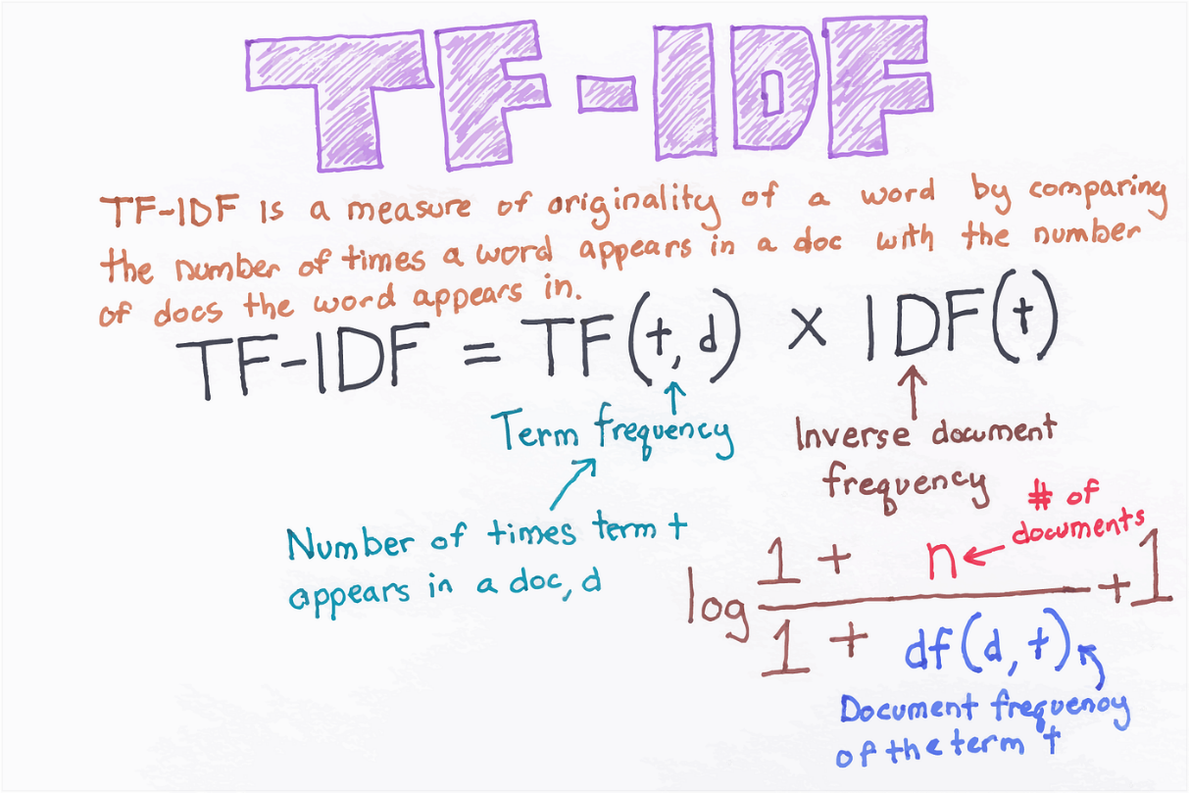
Figure 6: TF-IDF(Shubham Chouksey, 2020)

Machine Learning Algorithms/Models Implemented
Two classical machine learning models were adopted to classify binary sentiment (positive vs. negative):
- Logistic Regression: This is a binary probabilistic linear classifier. It uses a sigmoid to weigh sums of weighted features to provide probability (e.g., >0.5 to positive). It uses feature coefficients of word-sentiment associations to learn TF-IDF features. Regularization (L2) eliminates high dimensional overfitting(GeeksForGeeks, 2024a).
- Random Forest: This is an ensemble of decision trees, the aggregation of which is carried out by the majority vote. Every tree is conditioned on random sets of data/features, removing variance, and finding non-linear patterns (e.g. complex interaction of words). It gives feature importances, which can be used to evaluate sentiment drivers(Breiman, 2001).

Diagrammatic Representation

State Transition Diagram
A State Transition Diagram (also called a State Machine Diagram or Finite State Machine Diagram) is a graphical illustration of behaviour over time of a computer science system, software system, or system model(GeeksForGeeks, 2025a). It depicts:
- States: Possible discrete states or modes that the system may be in (e.g., "Idle" "Processing" "Error")(GeeksForGeeks, 2025a).
- Transitions: These are transitions between states caused by events, inputs, conditions, or actions (e.g. transition between Idle and Active is caused by Button Press)(GeeksForGeeks, 2025a).
- Events/ Triggers: The stimuli which elicits transitions (e.g. user input, timers, sensor data)(GeeksForGeeks, 2025a).
- Actions/Guards: optional aspects such as operations that are conducted between transition states or a condition that must be satisfied before the transition takes place(GeeksForGeeks, 2025a).
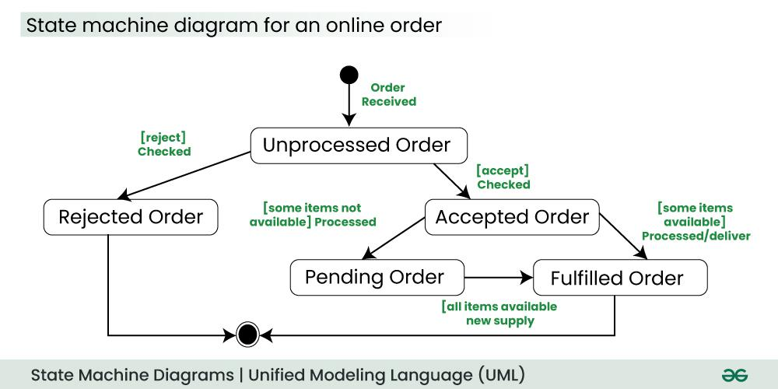
Figure 7: State Transition Diagram(GeeksForGeeks, 2025a)
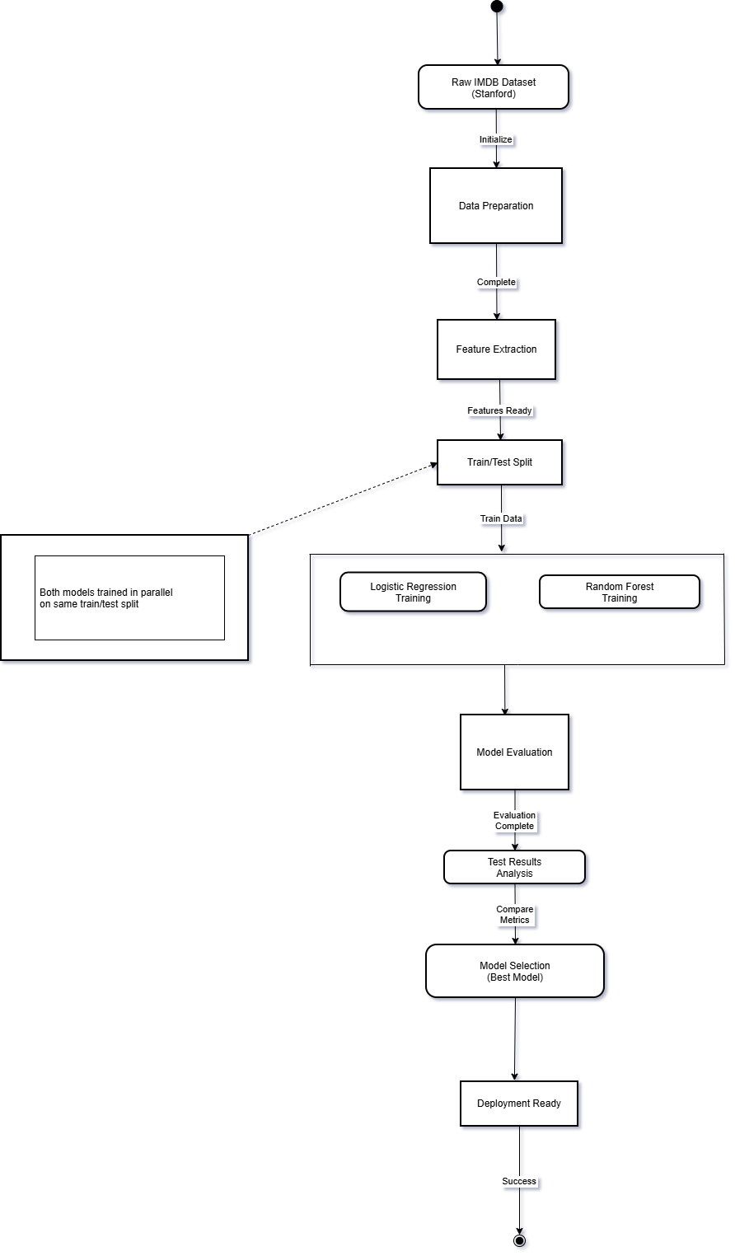
Figure 8: Whole System State Transition Diagram

Pseudocode

Data Loading & Preprocessing

FUNCTION LoadData(filepath)
dataset = READ_CSV(filepath)
reviews = dataset['review']
labels = dataset['sentiment']
RETURN reviews, labels
END FUNCTION

FUNCTION CleanText(text)
text = REMOVE_HTML_TAGS(text)
text = LOWERCASE(text)
text = REMOVE_URLS(text)
text = REMOVE_SPECIAL_CHARS(text)
text = REMOVE_NUMBERS(text)
text = REMOVE_WHITESPACE(text)
RETURN text
END FUNCTION

FUNCTION PreprocessReviews(reviews)
cleaned_reviews = []
FOR EACH review IN reviews
cleaned = CleanText(review)
cleaned_reviews.APPEND(cleaned)
END FOR
RETURN cleaned_reviews
END FUNCTION

FUNCTION Tokenize(reviews)
tokenized = []
FOR EACH review IN reviews
tokens = SPLIT(review)
tokenized.APPEND(tokens)
END FOR
RETURN tokenized
END FUNCTION

FUNCTION RemoveStopwords(tokenized_reviews)
stopwords = LOAD_STOPWORDS()
filtered = []
FOR EACH review IN tokenized_reviews
filtered_tokens = []
FOR EACH token IN review
IF token NOT IN stopwords
filtered_tokens.APPEND(token)
END IF
END FOR
filtered.APPEND(filtered_tokens)
END FOR
RETURN filtered
END FUNCTION

FUNCTION ExtractFeatures(reviews, method="TF-IDF", max_features=5000)
IF method == "TF-IDF"
vectorizer = TFIDF_VECTORIZER(max_features=max_features)
feature_matrix = vectorizer.FIT_TRANSFORM(reviews)
ELSE
vectorizer = COUNT_VECTORIZER(max_features=max_features)
feature_matrix = vectorizer.FIT_TRANSFORM(reviews)
END IF
RETURN feature_matrix, vectorizer
END FUNCTION

FUNCTION SplitData(features, labels, test_ratio=0.2, val_ratio=0.1)
total = LENGTH(features)
test_size = ROUND(total * test_ratio)
val_size = ROUND(total * val_ratio)
train_size = total - test_size - val_size

indices = SHUFFLE(0 TO total-1)

train_idx = indices[0:train_size]
val_idx = indices[train_size:train_size+val_size]
test_idx = indices[train_size+val_size:total]

X_train = features[train_idx]
X_val = features[val_idx]
X_test = features[test_idx]

y_train = labels[train_idx]
y_val = labels[val_idx]
y_test = labels[test_idx]

RETURN X_train, X_val, X_test, y_train, y_val, y_test
END FUNCTION

FUNCTION NormalizeFeatures(X_train, X_val, X_test)
mean = MEAN(X_train)
std = STD(X_train)

X_train = (X_train - mean) / std
X_val = (X_val - mean) / std
X_test = (X_test - mean) / std

RETURN X_train, X_val, X_test
END FUNCTION

FUNCTION PreprocessingPipeline(filepath, max_features=5000)
reviews, labels = LoadData(filepath)
cleaned_reviews = PreprocessReviews(reviews)
features, vectorizer = ExtractFeatures(cleaned_reviews, max_features=max_features)
X_train, X_val, X_test, y_train, y_val, y_test = SplitData(features, labels)
X_train, X_val, X_test = NormalizeFeatures(X_train, X_val, X_test)

RETURN {
X_train: X_train, X_val: X_val, X_test: X_test,
y_train: y_train, y_val: y_val, y_test: y_test,
vectorizer: vectorizer
}
END FUNCTION

Logistic Regression

BEGIN
LOAD dataset
PERFORM data cleaning
PERFORM text normalization
TOKENIZE text data
REMOVE stopwords
APPLY stemming or lemmatization
INITIALIZE vectorizer
TRANSFORM text data into feature vectors
INITIALIZE weights and bias
SET learning rate, regularization parameter, iterations
DEFINE Sigmoid(z)
RETURN 1 / (1 + exp(-z))
END
FOR each iteration
COMPUTE linear_output = DOT(features, weights) + bias
APPLY Sigmoid to obtain predictions
COMPUTE loss
ADD L2 regularization to loss
COMPUTE gradients of weights and bias
UPDATE weights and bias using gradient descent
END FOR
GENERATE predictions on test data
CALCULATE accuracy, precision, recall, and F1-score
END

Random Forest
BEGIN
IMPORT necessary libraries
ASSUME preprocessed_text_list and labels are available
SPLIT data into training and test sets X_train, X_test, y_train, y_test = train_test_split(preprocessed_text_list, labels, test_size=0.2, random_state=42, stratify=labels)
INITIALIZE vectorizer vectorizer = TfidfVectorizer(max_features=5000, ngram_range=(1,2))
TRANSFORM text data into feature vectors X_train_vectors = vectorizer.fit_transform(X_train) X_test_vectors = vectorizer.transform(X_test)
INITIALIZE RandomForestClassifier rf_classifier = RandomForestClassifier( n_estimators=200, criterion='gini', max_depth=None, min_samples_split=2, min_samples_leaf=1, max_features='sqrt', bootstrap=True, n_jobs=-1, random_state=42 )
TRAIN the Random Forest model rf_classifier.fit(X_train_vectors, y_train)
GENERATE predictions on test data y_pred = rf_classifier.predict(X_test_vectors)
CALCULATE evaluation metrics accuracy = accuracy_score(y_test, y_pred) precision = precision_score(y_test, y_pred, average='weighted') recall = recall_score(y_test, y_pred, average='weighted') f1 = f1_score(y_test, y_pred, average='weighted')
DISPLAY results
PRINT "Accuracy:", accuracy
PRINT "Precision:", precision
PRINT "Recall:", recall
PRINT "F1-Score:", f1
PRINT classification_report(y_test, y_pred)
END

Tools and technologies used

Tools and Technologies
Programming Language: Python
In this project, python is used as a main language for model development. Python is a programming language mainly used for backend systems and in machine learning(Python, 2024b).

Figure 9: Python(Python, 2024b)

Ms Word
Ms word is word processing application which was developed by Microsoft that allows users to create. edit and format text documents which is mainly used for documentation of assignments(Nafiul Khan Earth, 2024).

Figure 10: MS Word(Nafiul Khan Earth, 2024)
Google Colab Notebook
A Google Colab notebook is an online interactive environment provided by Google where users can write and execute Python code directly in a web browser. It allows you to combine code, text, equations, and visualizations in a single document called a notebook(Google, 2024).

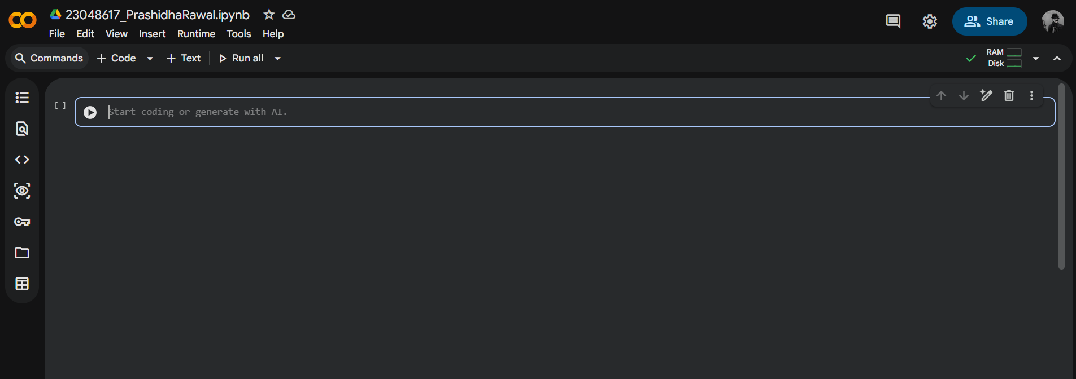
Figure 11: Screenshot Taken from Desktop of Google Colab Notebook

Github
GitHub is a website where people store, share, and work together on code.
It lets developers upload their projects, track changes over time, and collaborate with others without overwriting each other’s work(Sebastian De Lima Follow, 2020).
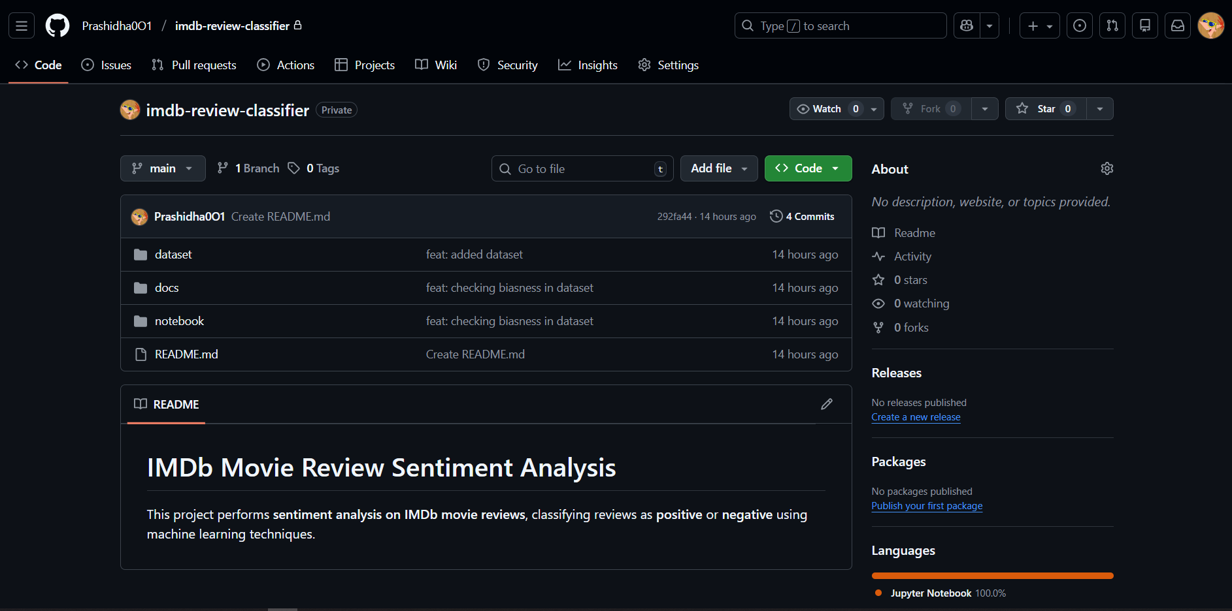
Figure 12:Screenshot taken from Desktop of Github
Kaggle
Kaggle is an online platform for data science and machine learning where people learn, practice, and compete using real datasets. It offers datasets, coding notebooks, courses, and competitions so users can build models, analyze data, and improve their skills in one place(Maria Gusarova, 2022).
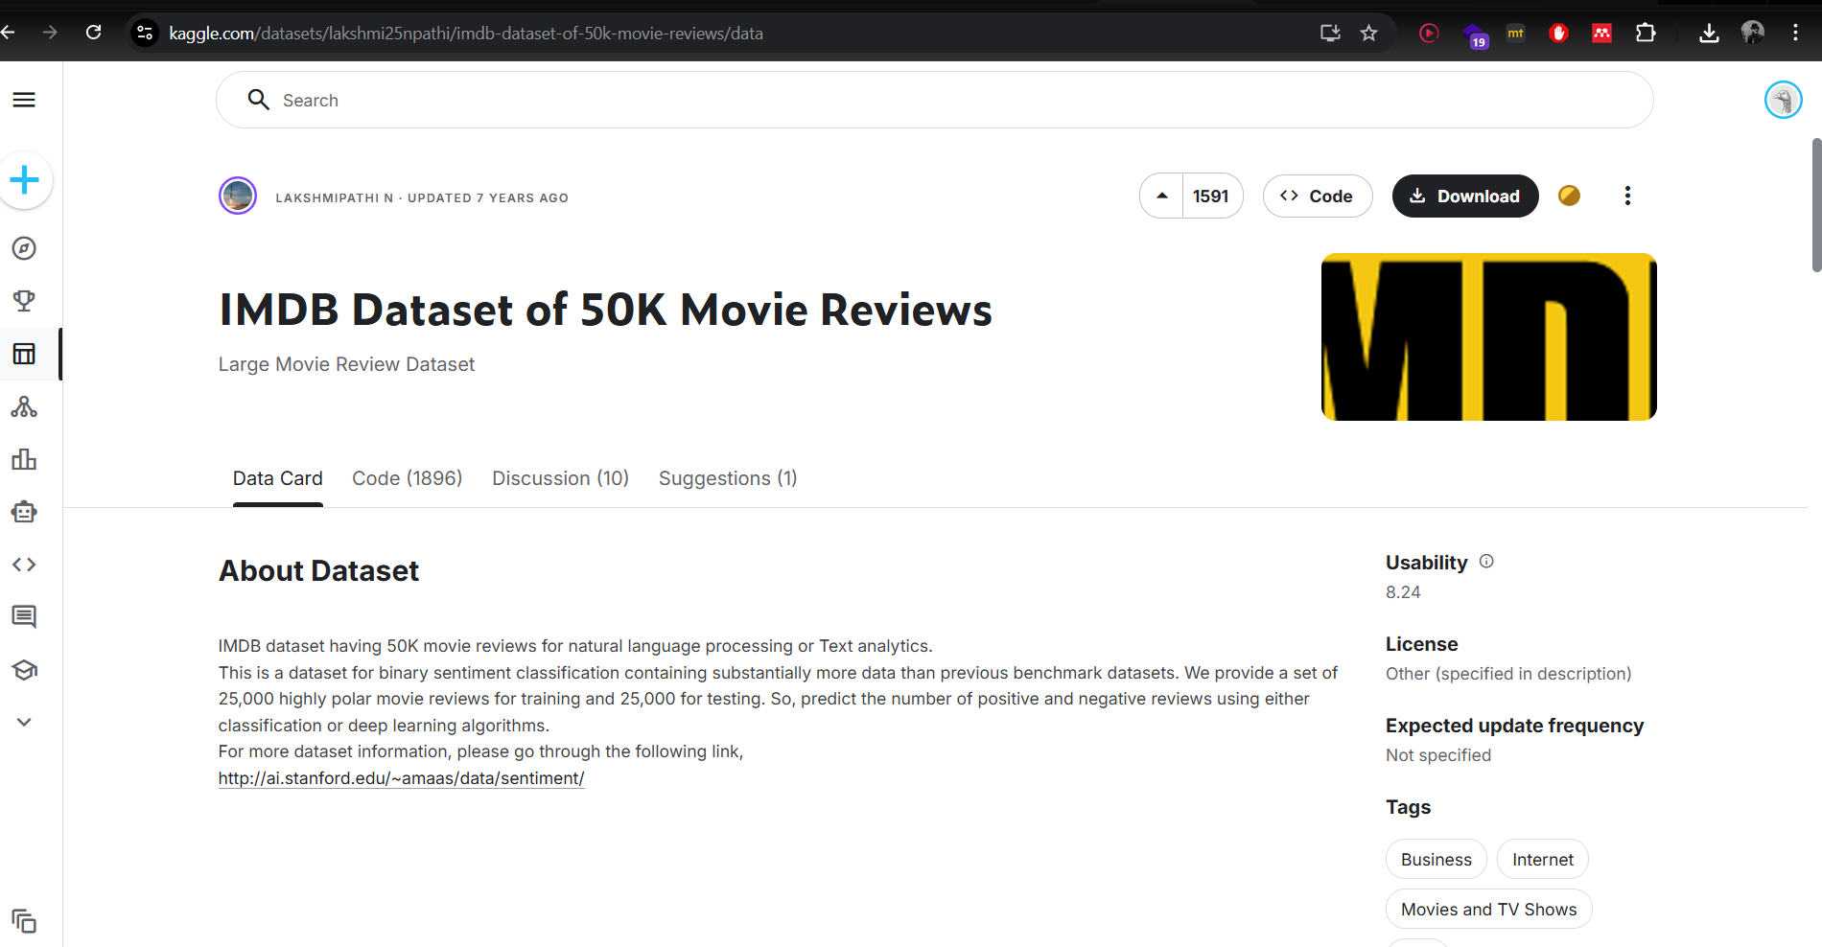
Figure 13: Screenshot taken from Desktop of Kaggle

Libraries
Pandas
Pandas is a python library used in data manipulation and analysis. It provides data structure for analysis and cleaning(Niraj Tiwari, 2024).
Seaborn
Seaborn (as sns) is a statistical data visualization library built on top of matplotlib, offering a high-level interface for drawing attractive and informative graphics like heatmaps, violin plots, and pair plots with less code(Waskom, 2021).
Counter
Counter from the collections module is a specialized dictionary subclass for counting hashable objects, making it easy to tally frequencies of elements like words in text data(kristi, 2010).
Warnings
Warning is a python library which is used to filter out warning messages in notebook.
MatplotLib
It is a plotting Libarary used for creating static, animated and interactive visualizations(Matplotlib, 2024).

Bibliography
Breiman, L., 2001. Random forests. Machine Learning, [online] 45(1), pp.5–32. https://doi.org/10.1023/A:1010933404324.
DataCamp, 2024. What is Tokenization? Types, Use Cases, Implementation | DataCamp. [online] Available at: <https://www.datacamp.com/blog/what-is-tokenization> [Accessed 15 December 2025].
GeeksForGeeks, 2024a. Logistic Regression in Machine Learning - GeeksforGeeks. [online] Available at: <https://www.geeksforgeeks.org/machine-learning/understanding-logistic-regression/> [Accessed 15 December 2025].
GeeksForGeeks, 2024b. Random Forest Algorithm in Machine Learning - GeeksforGeeks. [online] Available at: <https://www.geeksforgeeks.org/machine-learning/random-forest-algorithm-in-machine-learning/> [Accessed 15 December 2025].
GeeksForGeeks, 2024c. What is Text Classification? - GeeksforGeeks. [online] Available at: <https://www.geeksforgeeks.org/nlp/what-is-text-classification/> [Accessed 15 December 2025].
GeeksForGeeks, 2025a. State Machine Diagrams | Unified Modeling Language (UML) - GeeksforGeeks. [online] Available at: <https://www.geeksforgeeks.org/system-design/unified-modeling-language-uml-state-diagrams/> [Accessed 15 December 2025].
GeeksForGeeks, 2025b. Text Preprocessing in NLP - GeeksforGeeks. [online] Available at: <https://www.geeksforgeeks.org/nlp/text-preprocessing-for-nlp-tasks/> [Accessed 15 December 2025].
Google, 2024. Google Colab. [online] Available at: <https://colab.google/> [Accessed 15 December 2025].
kristi, 2010. Python Counter class. [online] Available at: <https://gist.github.com/kristi/835743> [Accessed 15 December 2025].
Maas, A.L., Daly, R.E., Pham, P.T., Huang, D., Ng, A.Y. and Potts, C., n.d. Learning Word Vectors for Sentiment Analysis.
Maria Gusarova, 2022. Kaggle. [online] Available at: <https://medium.com/@data.science.enthusiast/what-is-kaggle-com-why-should-i-use-it-as-a-beginner-data-scientist-how-do-i-get-started-with-it-7e218266fe6d> [Accessed 15 December 2025].
Matplotlib, 2024. Matplotlib — Visualization with Python. [online] Available at: <https://matplotlib.org/> [Accessed 15 December 2025].
Nafiul Khan Earth, 2024. Mastering MS Word: A Beginner’s Guide to Getting Started (Day 1) | by Nafiul Khan Earth | MS Word, Excel and PowerPoint tutorials for biginners | Medium. [online] Available at: <https://medium.com/ms-word-excel-and-powerpoint-tutorials-for/mastering-ms-word-a-beginners-guide-to-getting-started-day-1-262c9eaa87f1> [Accessed 15 December 2025].
Niraj Tiwari, 2024. Pandas 101 : A Comprehensive Guide to Mastering Data Analysis with Python’s Pandas Library | by Niraj Tiwari | Medium. [online] Available at: <https://medium.com/@niraj.e21/pandas-101-dccdc78c2248> [Accessed 15 December 2025].
Python, 2024a. RandomForestClassifier — scikit-learn 1.8.0 documentation. [online] Available at: <https://scikit-learn.org/stable/modules/generated/sklearn.ensemble.RandomForestClassifier.html> [Accessed 15 December 2025].
Python, 2024b. Welcome to Python.org. [online] Available at: <https://www.python.org/> [Accessed 15 December 2025].
Sebastian De Lima Follow, 2020. Github. [online] Available at: <https://medium.com/swlh/what-is-github-423f9049ab2d> [Accessed 15 December 2025].
Shubham Chouksey, 2020. Demonstrating Calculation of TF-IDF From Sklearn | by Shubham Chouksey | Analytics Vidhya | Medium. [online] Analytics Vidhya. Available at: <https://medium.com/analytics-vidhya/demonstrating-calculation-of-tf-idf-from-sklearn-4f9526e7e78b> [Accessed 15 December 2025].
Waskom, M., 2021. seaborn: statistical data visualization. Journal of Open Source Software, 6(60), p.3021. https://doi.org/10.21105/JOSS.03021.

